A STUDY OF GRIEF IS AS A NORMAL AND NATURAL RESPONSE WHEN WE SUFFER A LOSS.

(Student Name)
Research III
Research Paper

Southern University at New Orleans
School of Social Work
Dr. Enchante’ Franklin

Presented to:
Research III Fall Class
November 11, 2020 (Draft 2)

LIST OF ABBREVATIONS

PGD – Prolonged Grief Disorder

Introduction
Grief is a normal part of coping with a loss, but for some people, it can be far more serious. In some situations, normal grief can lead to a grief disorder, which can require professional help to overcome. While grief imparts attributes to the gloom, it's anything but confusion. Grief is a characteristic procedure that everybody experiences subsequent to losing a friend or family member. The excruciating feelings of anguish emerge from the serious intensity of the human bond. The associations we make with our loved ones don't disseminate after somebody kicks the bucket. Rather, these bonds endure considerably in the afterlife. Grief is the process by which a person adjusts to the physical absence of someone with whom they continue to have a psychological or spiritual relationship. Despite their otherworldly or strict convictions, the vast majority keep on encountering the nearness of friends and family after their demises. Individuals state that their friends and family live on in their souls, alluding not exclusively to recollections they share yet to the profound feelings and the feeling of quality they feel. By experiencing progressive phases of anguish, an individual figure out how to acknowledge the misfortune and discover harmony and even bliss in great recollections and continuing sentiments of adoration. Grief research has typically centered on one time, without considering the impact of multiple losses over time.
Purpose of study
The purpose of this study was to determine the important areas for clinical intervention. Specifically, the both loss groups may be a prime target for intervention given that they experienced the most grief symptomatology and the most losses. Past loss has the potential to result in negative life events that may make it difficult to cope with a loss later in life. Therefore, early intervention is a key in helping individuals understand the loss and heal from it to prevent later negative effects. Given that this was a sample of emerging adult college students; it may be beneficial for the campus community to provide additional support to those who have experienced loss. In addition to individual therapy, a variety of counseling mediums may prove to aid in the process of coping with loss and trauma, such as therapist-led family counseling, group counseling, and student-led support groups. Accordingly, dissociation increase symptoms of distress and PGD via the impairment in the integration process. Narrative reconstruction therapy seem to be an appropriate method to address this process and consequently to help bereaved individuals in reducing their distress. While doing narrative reconstruction, therapist should be aware of personal characteristics and event characteristics that are related to elevated levels of distress, as mentioned above. Further, it may be useful for on campus counselors to investigate and implement-specific treatment modalities and interventions targeting those who have experienced loss, such as cognitive behavioral grief treatment, complicated grief therapy, a solution-focused crisis intervention modality, or therapeutic art techniques. Our sample was a nonclinical sample with subclinical levels of psychopathology as manifested by their PGD symptoms and general distress, a factor that limited our ability to reach conclusions regarding individuals with higher levels of PGD symptoms and distress. In addition, the methodology of this study was cross-sectional, making it difficult to draw conclusions regarding the longitudinal effects of dissociation on integration of the memory of the loss and psychological distress in the aftermath of the loss. While study limitations also stem from the fact that the participants varied with regard to the circumstances of their loss, the time since their loss occurred, and the closeness of the relationship they had with the deceased, this study does allow for a wider generalization of findings to individuals who have experienced a broad range of types of losses.

Statement of the Problem
Research Questions
1. RQ1: Is there a significant relationship between levels of grief and the stages of grief?
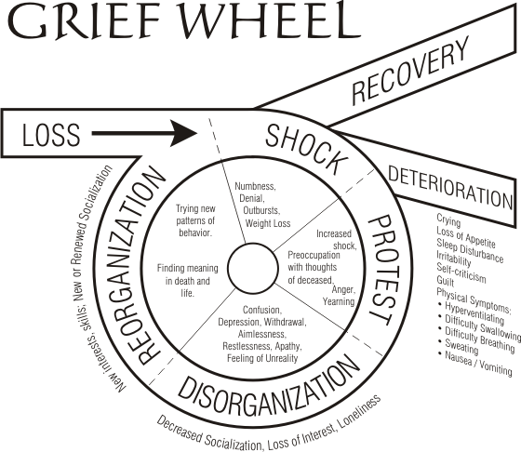
2. RQ2: Is there a significant relationship between grief symptoms and end of life? A signiﬁcant minority of bereaved people develops debilitating symptoms of depression, anxiety and/or PGD (previously called complicated grief, CG; Prigerson et al., 2009). PGD is characterized by persistent yearning for the lost person, difﬁculties to accept the loss, a shattered sense of identity, numbness and avoidance of reminders of the loss, present to the point of functional impairment. PGD symptoms can have debilitating health consequences. Therefore, it is important to explore mechanisms that are possibly involved in their development and maintenance. The present study examined future directed thinking as one such mechanism. Bereaved individuals are confronted with many challenging situations. They are faced with new tasks, responsibilities and roles and have to deal with practical consequences of their loss. Recovery hinges on their ability to incorporate their loss into a positive view of self and life and to continue (or restore) activities that are satisfying and meaningful. It seems plausible that the ability to effectively progress towards valued goals is an integral part of recovery and that problems with such goal pursuit can block recovery. Notably, the inability to progress towards valued goals is implicated in different theoretical models of PGD maintenance (Boelen, van den Hout, & van den Bout, 2006; Stroebe & Schut, 1999). The present study aimed to enhance knowledge about future directed thinking in grief by examining goals (i.e., positive states that the person wishes to accomplish or attain or negative states he or she wishes to avoid; cf. Vincent, Boddana, & MacLeod, 2004) of bereaved people and their association with PGD symptom severity. Weiss (2002) suggested that normative reactions to a death take on two forms, protest and despair. The protest form of grief consists of preoccupation with the loss, waves of pain, agitation, and tension. The despair form of grief represents an individual’s decreased attentiveness to the environment and physiological arousal. These characteristic reactions manifest in most people who endure a loss. However, those who experience a sense of persistent yearning, disbelief, and resisting acceptance of the death for at least 6 months after the death to the point of functional impairment follow a maladaptive pattern of bereavement (Ott, Lueger, Kelber, & Prigerson, 2007; Prigerson et al., 2009; Shear & Shair, 2005).
Hypotheses
It is hypothesized that resilience, depression, and grief will vary depending on whether the participant experienced a recent loss, a past loss, or a combination of losses. Due to the time passed since the loss, which allows for the adoption of coping strategies, it is expected that those who went through a past loss will have higher resilience, and less grief and depression than those who experienced a recent loss. For individuals who faced both past and recent losses, a clear hypothesis regarding resilience, depression, and grief does not emerge. It is possible that experiencing a past loss will provide a protective aspect to a recent loss such that those who went through a past loss will have more resilience, fewer maladaptive grief reactions, and less depressive symptoms in relation to the loss they later incurred. This may occur because emerging adults who have already gone through an earlier loss likely developed coping strategies in response to the past death. On the other hand, due to the multiple negative outcomes associated with experiencing a loss (Fried et al., 2015; Reinherz, Giaconia, Hauf, Wasserman, & Silverman, 1999), it may be that an earlier loss decreases resilience in adulthood and the cumulative nature of multiple losses leads to more maladaptive grief reactions and higher amounts of depressive symptoms.
Independent and Dependent variables from your study

Data were used from an ongoing study about correlates and treatment of psychopathology in relatives of missing persons (Lenferink, van Denderen et al. 2017; Lenferink et al., 2016). Adults fluent in Dutch whose spouse, family member, or friend was missing for at least three months were eligible to participate. Data for the current study were collected between July 2014 and July 2016. The following definition of a missing person was used in the current study: ‘Anyone whose whereabouts is unknown whatever the circumstances of disappearance. They will be considered missing until located and their well- being or otherwise established’ (Association of Chief Police Officers, 2010, p. 15). Despite these limitations, the current study is the first that examined the associations between self-compassion and psychopathology levels in the context of grief and loss. Although more research is needed to draw firm conclusions about these associations among people con- fronted with the loss of a loved one, the results of our study suggest that fostering self-compassion in treatment might reduce post-loss psychopathology levels by reducing ruminative tendencies. There is evidence that enhancement of self-compassion and reduction of ruminative tendencies are mechanisms of change in mind- fullness-based treatments for recurrent depression (van der Velden et al., 2015).
Literature Review
From the literature examined, it seems are though there are three key social factors which determine the likelihood that a person will experience the negative symptoms associated with disenfranchised or complicated grief: lack of support, low socio-economic status and shame. It is important to note that the revolving doors cohort will likely experience all three.

Gaps in literature

Framework
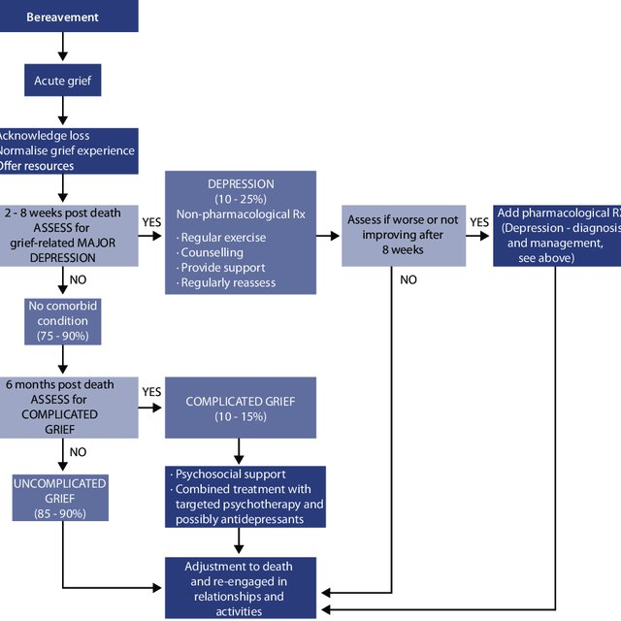
Methodology
The key themes introduced in this paper are based on the literature on loss, dying and bereavement, largely taken from peer-reviewed journals and other academic texts, as well as significant voluntary sector and user-led research, and commissioning guidelines and materials. With regard to ambiguous losses, there is necessarily overlap between ‘impact’ and ‘subject’ as set out in the table. For instance, loss of physical health can be a consequence of the loss of a close relationship but it can also be classified as a loss in and of itself. However, this did not impede the search because one term from each column was used in each search. Quite often, the research reviewed was heavily focused on loss in a criminal justice context. This is because the impact of grief and loss on the likelihood that someone will experience homelessness, sex work, problematic drug or alcohol use and mental ill health is relatively unexplored as yet. Adam (2014) note that, for instance, ‘the literature available specifically on drug and alcohol related bereavement is not extensive’. There is evidence that the majority of the prison population have one or more diagnosable mental health problems (Singleton et al., 1998; Stewart 2008; Rebalancing Act 2017) and it is widely acknowledged that the homeless population will experience repeated bereavements which leaves them more at risk of isolation, loneliness, depression, suicidal ideation (Lakeman, 2011). Therefore, although there is an unavoidable focus on the criminal justice system in this review, the themes explored and the conclusions reached are not entirely divorced from the overarching issues of multiple disadvantage. As Vaswani (2018) acknowledges, “many of these losses and traumas have occurred, and have been left to go unresolved, long before the prison gates are reached”. Database searching for this paper took place between April and June 2018. As well as the database search, we issued a call for evidence to our network of multidisciplinary researchers, and experts in the field advised on key authors. We prioritized academic materials and peer-reviewed papers but used grey literature to fill particularly pertinent gaps in the literature.
Recommendations for Social Work

Conclusion
Suppose the loss has had detrimental effects on the bereaved person’s life, and they seek help sometime after the loss. In that case, it can help acknowledge the role of the loss on the person’s maladaptive behaviors (e.g., offending, drug misuse). It is quite common for people who have experienced loss in childhood or young adulthood to revisit their grief, experience and express it in new ways, and develop understandings of the meaning that the death has played in their lives. That this is the first step towards a healthy grieving and rehabilitation process. This can also help with resolving shame and understanding their behavior, which has been shown to significantly

References
Boelen, P.A., Van Den Hout, M.A., & Van Den Bout, J. (2006). A cognitive–behavioral conceptualization of complicated grief. Clinical Psychology, 13, 109–128.
(Chair, G & Davies, Natasha & Freeman, Carla & Joska, John & Pahad, S & Thom, Rita & Thompson, K & Woollett, Nataly. (2013). Management of mental health disorders in HIV-positive patients by the Southern African HIV Clinicians Society. SAJHIVMED. 14. 155. 10.7196/SAJHIVMED.995.
Fried, E. I. (2015). From loss to loneliness: The relationship between bereavement and depressive symptoms. Journal of abnormal psychology, , 124 (2), 256. doi:10.1037/abn0000028.
Lakeman, R. (2011). How Homeless Sector Workers Deal with the Death of Service Users: A Grounded Theory Study. Death Studies, 35(10), pp.925-948.
Lenferink, L. I. (2016). Cognitive behavioural therapy for psychopathol- ogy in relatives of missing persons: Study protocol for a pilot randomised controlled trial. Pilot and Feasibility Studies, , 2(1). doi:10.1186/s40814-016-0055-1.
Ott, C. H., Lueger, R. J., Kelber, S. T., & Prigerson, H. G. (2007). Spousal bereavement in older adults: Common, resilient, and chronic grief with defining characteristics. The Journal of Nervous and Mental Disease, 195(4), 332–341. doi:10.1097/01.nmd.0000243890.93992.1e
Prigerson, H.G., Horowitz, M.J., Jacobs, S.C., Parkes, C.M., Aslan, M., Goodkin, K., Raphael, B., Marwit, S.J., Wortman, C., Neimeyer, R., Bonanno, G.A., Block, S.D., Kissane, D., Boelen, P.A., Maercker, A., Litz, B., D.W., Johnson, J.G., First, M.B., & Maciejewski, P.K. (2009). Prolonged Grief Disorder: Psychometric validation of criteria proposed for DSM-V and ICD-11. PLoS Medicine, 6(8), e1000121.
Prigerson, H. G., Horowitz, M. J., Jacobs, S. C., Parkes, C. M., Aslan, M., Goodkin, K., … Maciejewski, P. K. (2009). Prolonged grief disorder: Psychometric validation of criteria proposed for DSM-V and ICD-11. PLOS Medicine, 10(12), e1000121. doi:10.1371/journal.pmed.1000121
Reinherz, H. Z. (108(3), 500–510. doi:10.1037/ 0021-843X.108.3.500). Major depression in the transition to adulthood: Risks and impairments. Journal of Abnormal Psychology, , 1999.
Shear, K., & Shair, H. (2005). Attachment, loss, and complicated grief. Developmental Psychobiology, 47(3), 253–267. doi:10.1002/dev.20091

van der Velden, A. M. (2015). A systematic review of mechanisms of change in mindfulness-based cog- nitive therapy in the treatment of recurrent major depressive disorder. Clinical Psychology Review,, 37, 26–39.
Vaswani, N. (2018). Ambiguous Loss. Scottish Journal of Residential Child Care, [online] 17.3. Available at: https://www.celcis.org/files/7715/3717/6627/2018_Vol_17_No_3_Vaswani_N_Ambiguous_Loss.pdf [Accessed 26 Nov. 2018].
Vincent, P.J., Boddana, P., & MacLeod, A.K. (2004). Positive life goals and plans in parasuicide. Clinical Psychology and Psychotherapy, 11, 90–99.
Weiss, R. S. (2002). Grief, bonds, and relationships. In M. S. Stroebe, R. O. Hansson, W. Stroebe, & H. Schut (Eds.), Handbook of bereavement research: Consequences, coping, and care (pp. 47–62). Washington, DC: American Psychological Association.

